DA505 HOMEWORK 1 - FALL 2021 (SOLUTIONS)

Q1.(5 Pts) Given the following table.

Project Name | Project No | Project Manager | Project Budget | Employee No | Employee Name | Department No | Department Name | Daily Rate
Billing | PRJ010 | King | 11500 | 10001 | Steve | D004 | Development | 17.50
Billing | PRJ010 | King | 11500 | 10030 | Bill | D023 | Analysis | 16.50
Billing | PRJ010 | King | 11500 | 21010 | Robert | D004 | Development | 21.00
HR System | PRJ064 | Sarah | 21750 | 31002 | Moira | D028 | Database | 23.25
 |  |  |  | 21010 | Robert | D004 | Development | 17.50
 |  |  |  | 10034 | James | D009 | Network | 16.50
Ecommerce | PRJ045 | Julia | 12150 | 10010 | Jones | D004 | Development | 21.75
Ecommerce | PRJ045 | Julia | 12150 | 10001 | Steve | D004 | Development | 17.50
Ecommerce | PRJ045 | Julia | 12150 | 31002 | Moira | D028 | Database | 25.50
Ecommerce | PRJ045 | Julia | 12150 | 13210 | Lisa | D008 | Security | 17.00
Billing | PRJ010 | King | 11500 | 10001 | Steve | D004 | Development | 17.50
 |  |  |  | 10030 | Bill | D023 | Analysis | 16.50
 |  |  |  | 21010 | Robert | D004 | Development | 21.00
Loyalty | PRJ065 | Sarah | 21750 | 31002 | Moira | D028 | Database | 25.50
Loyalty | PRJ065 | Sarah | 21750 | 21010 | Robert | D004 | Development | 17.50
Loyalty | PRJ065 | Sarah | 21750 | 10034 | James | D009 | Network | 16.50
Ecommerce | PRJ045 | Julia | 12150 | 10010 | Jones | D004 | Development | 21.75
 |  |  |  | 10001 | Steve | D004 | Development | 17.50
 |  |  |  | 31002 | Moira | D028 | Database | 25.50
 |  |  |  | 13210 | Lisa | D008 | Security | 17.00

Please normalize the above scheme through 1st, 2nd and 3rd normal forms.
Any answer, other than the solution might be accepted, provided that your design is consistent within itself.

1NF

PROJECTS (PojectNo, ProjectName, ProjectManager, ProjectBudget)
EMPLOYEES (ProjectNo, EmployeeNo, EmployeeName, DepartmentNo, DepartmentName, DailyRate)

2NF

PROJECTS (PojectNo, ProjectName, ProjectManager, ProjectBudget)
EMP_PRJ (PojectNo, EmployeeNo, DailyRate)
EMPLOYEES (EmployeeNo, EmployeeName, DepartmentNo, DepartmentName)

3NF

PROJECTS (PojectNo, ProjectName, ProjectManager, ProjectBudget)
EMP_PRJ (PojectNo, EmployeeNo, DailyRate)
EMPLOYEES (EmployeeNo, EmployeeName, DepartmentNo)
DEPARTMENTS (DepartmentNo, DepartmentName)

Q2. (5 Pts) Given the following universal scheme.

BOOKSTORE

BookID
BookName
Price
OrderID
OrderDate
Quantity
CustomerID
CustomerName
StreetAddress
City
State
EmailAddress
PhoneNumber
AuthorID
AuthorName

Business Rules:

Every customer can make one or more orders
An order can be given by only one customer
An order can include one or more books
A book can be ordered in one or more orders
An author can write one or more books
A book can be writen by only one author

Functional Dependencies:

OrderID OrdereDate, Quantity
BookID BookName, Price
AuthorID AuthorName
CustomerID CustomerName, StreetAddress, City, State, EmailAddress, PhoneNumber

Please normalize the above scheme through 1st, 2nd and 3rd normal forms.
Any answer, other than the solution might be accepted, provided that your design is consistent within itself.

1NF

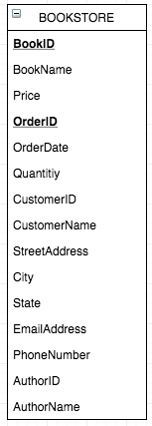

2NF

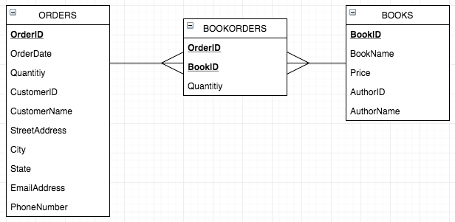

3NF

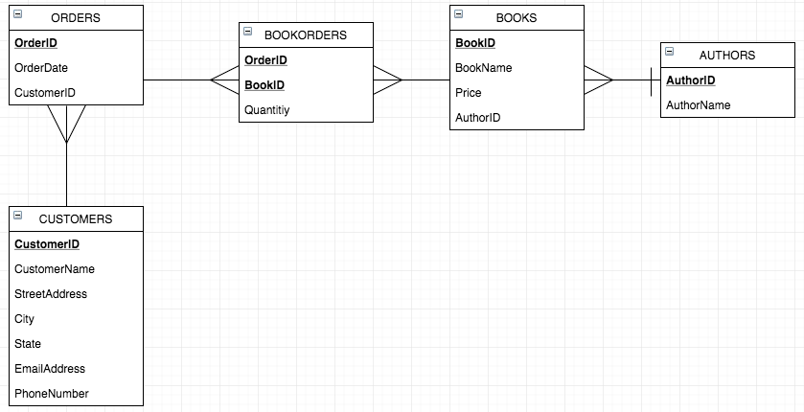

Q3. (5 Pts)

BOOK (Book_title, Authorname, Book_type, Listprice, Author_affil, Publisher)

Author_affil referes to the affiliation of the author. Suppose the following dependencies exist:

Book_title --> Publisher, Book_type
Book_type --> Listprice
Author_name --> Author-affil

(a) What normal form is the relation in ? Explain your answer.
(b) Apply normalization until you cannot decompose the relations further. State the reasons behind each decomposition.

- The key for this relation is BookTitle, AuthorName. With this key, relation is in the 1st normal form. There is no multi-valued attributes.

2nd Normal Form:

The primary key of the given relation is a composite one: book_title+authorname.
To move to the second normal formal we need to eliminate partial dependencies on the primary key. That would lead us to create multiple relations.

Book_title | Publisher | Book_type | Listprice
BOOK

Authorname | Author_affil
AUTHOR

Book_title | Authorname
BOOK_AUTHOR

3rd Normal Form:

3rd normal form requires elimination of transitive relations.
AUTHOR and BOOK_AUTHOR relations defined above have already satisfied this condition.
However, Listptice attribute in the BOOK relation is dependent on a non-key attribute of this relation, Book_type. To eliminate this transitive dependency we need to create another relation, PRICE_LIST.
All relations in the third normal form are stated below:

Book_title | Publisher | Book_type
BOOK

Authorname | Author_affil
AUTHOR

Book_title | Authorname
BOOK_AUTHOR

Book_type | Listprice
PRICE_LIST

